Experiment No: 08
Experiment Name: Traversing, Searching, Insertion and Deletion in a Doubly Linked List and Circular Linked List
Objectives:
- To implement Doubly Linked List and Circular Linked List and perform operations such as traversal, searching, insertion and deletion
- To understand dynamic memory management, pointer manipulation and optimized data structures for efficient data handling
Theory:
A Doubly Linked List is a linear dynamic data structure where each node contains data, a pointer to the next node and a pointer to the previous node. Traversal can be performed in both forward and backward directions
A Circular Linked List is a variation where the last node points back to the head, allowing circular traversal. These structures allow dynamic insertion and deletion at any position efficiently compared to static arrays
Algorithms:
1.1 | Traversal (Doubly Linked List):
- Start from head
- Move forward using next pointer and display each node
- Move backward from last node using prev pointer
1.2 | Traversal (Circular Linked List):
- Start from head
- Move forward using next until reaching head again
2 | Searching:
- Start from head
- Compare each node’s data with the target
- If found, display the position; otherwise, continue
3 | Insertion:
- Beginning: Update head and node pointers
- End: Traverse to last node, update pointers
- Specific Position: Traverse and adjust pointers to insert
4 | Deletion:
- Beginning: Update head, adjust pointers, free node
- End: Traverse to last node, update previous node’s pointer, free node
- Specific Position: Traverse, update adjacent nodes, free node
Code:
Doubly Linked List:
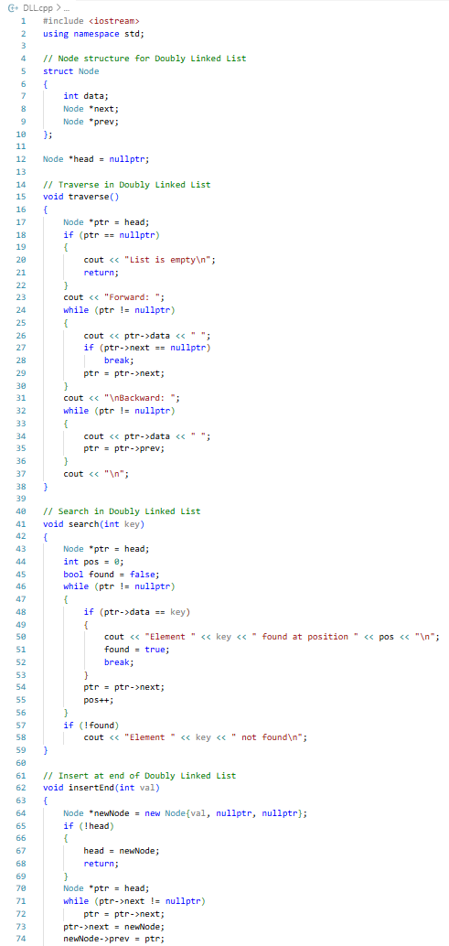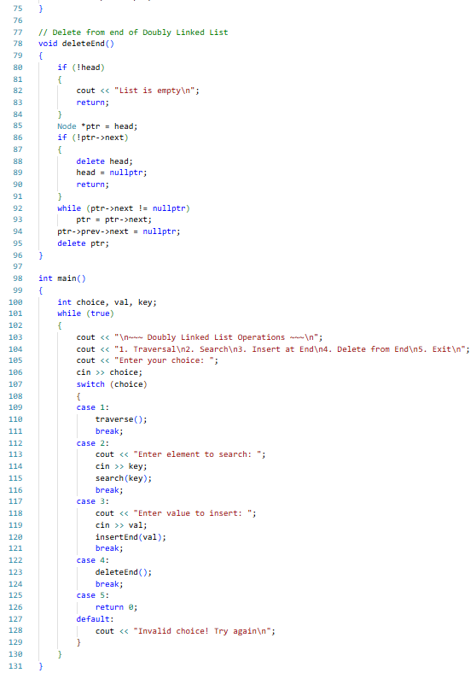

Circular Linked List:
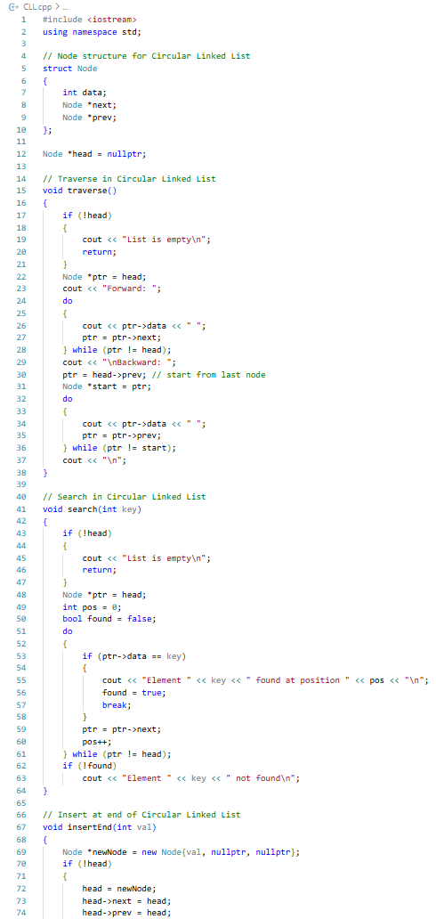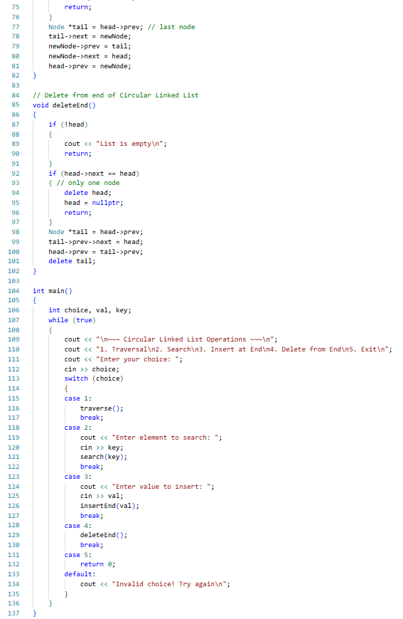
Procedure:
- VS Code was opened and a new project was created
- The Doubly Linked List code was written, compiled and syntax errors fixed
- Menu driven operations such as Traversal, Search, Insert, Delete were performed and changes were verified after each action
- Forward and backward traversal was observed to ensure correctness and memory was freed when nodes were deleted
- The Doubly Linked List code was extended to the Circular Linked List by linking the last node to head and updating head->prev
- The Circular Linked List operations were tested, ensuring traversal, insertion and deletion maintained proper circular links
Results:
Doubly Linked List:
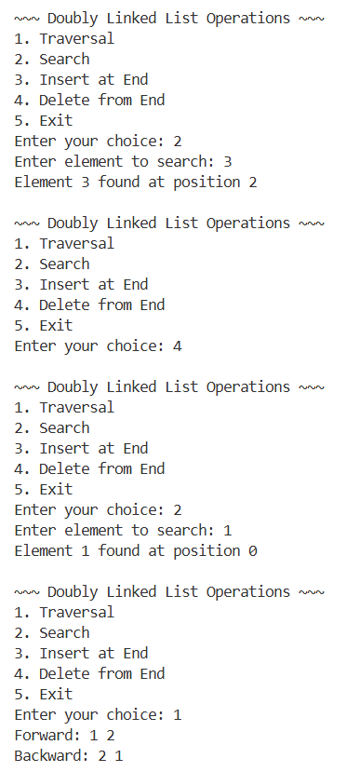
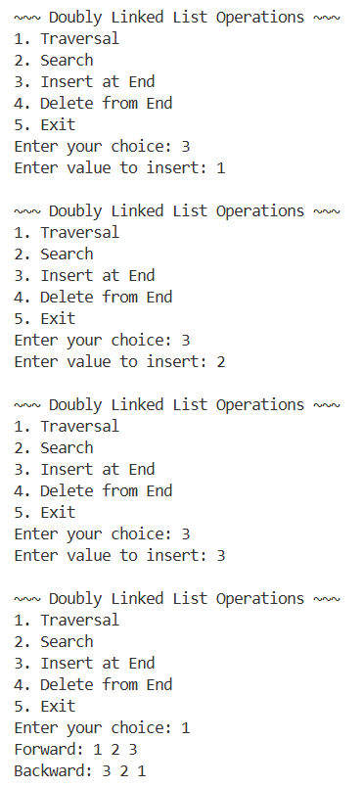
Circular Linked List:
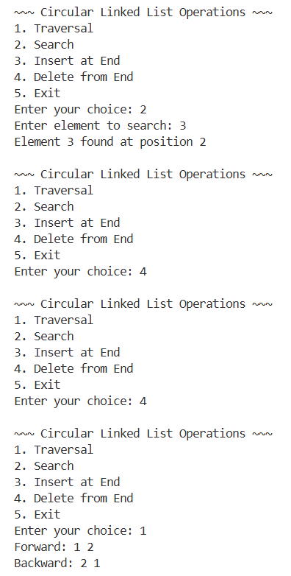
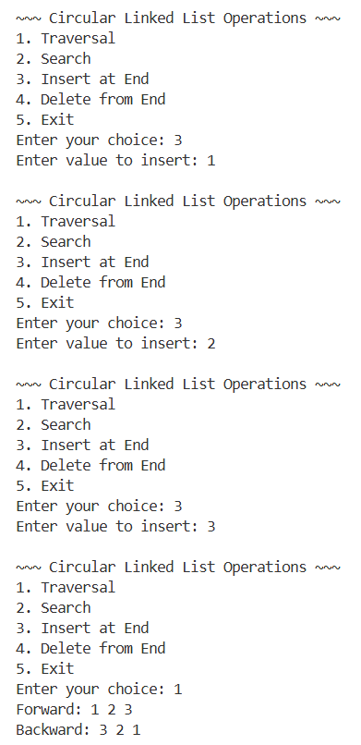
Complexity Analysis:
Operation | Time Complexity | Space Complexity
Traversal (DLL/CLL) | O(n) | O(1)
Searching | O(n) | O(1)
Insertion at beginning | O(1) | O(1) per node
Insertion at end | O(n) | O(1) per node
Deletion at beginning | O(1) | O(1)
Deletion at end | O(n) | O(1)
Precautions:
- Always checked for NULL pointers before accessing nodes
- Validated positions for insertion and deletion to avoid segmentation faults
- Freed memory of deleted nodes to prevent memory leaks
- Avoided negative or invalid indices during operations

Limitations:
- Random access is inefficient compared to arrays
- Operations require pointer manipulation, which may lead to errors if not careful
Conclusion:
This experiment provided hands on experience in implementing and manipulating Doubly Linked Lists and understanding the logic for Circular Linked Lists. By completing this lab, we gain a solid understanding of advanced pointer based dynamic data structures, foundational for stacks, queues and complex structures like graphs

